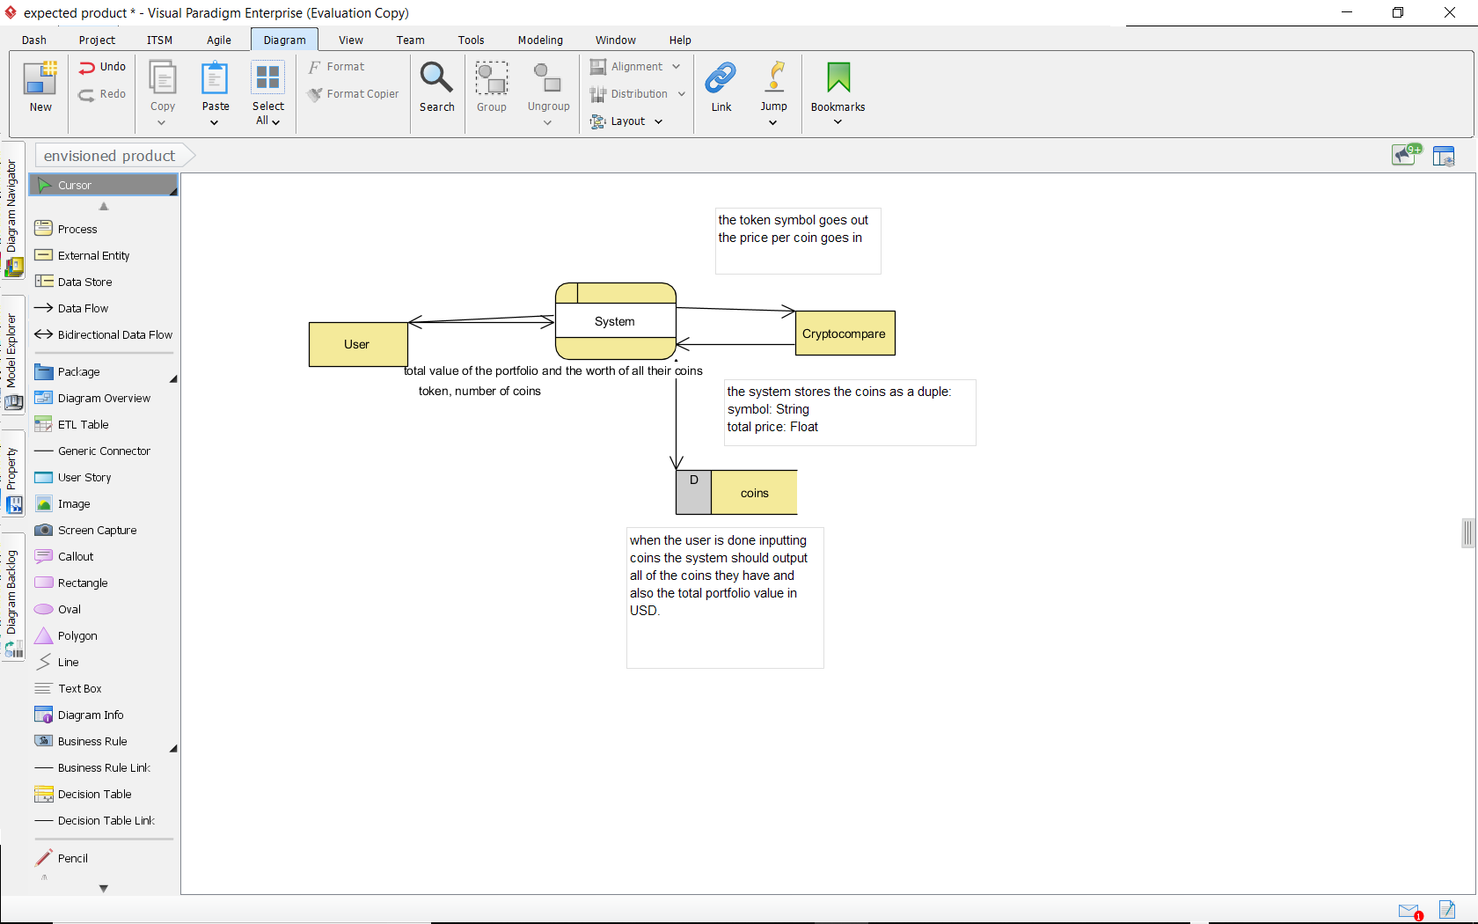

Here is my pseudocode for my for this

var I = 0

Var coin = {token: “”, price: 0};

var input

do{

input = ask the user for their crypto token or if they are done to enter 0

var num =ask for the number of coins they have

var price_per_coin=(ask the cryptocompare api for the price per coin)

coin[i++] = {input, num * price_per_coin}

var sum +=, num * price_per_coin

}While input !=0

Then I could output the sum and my array of coins